Chapter 4 Smith Exercises & Labs

Exercise 4-1.

1. What is the exact output when this program executes?

My Age: 17

Able To Vote: No

1. What is the exact output if the value of **myAge** is changed to **19**?

My Age: 19

Able To Vote: Yes

1. What is the exact output if the value of **myAge** is changed to **18** and the expression in the **if** statement is changed to **myAge <= VOTING_AGE**?

My Age: 18

Able To Vote: No

1. What is the exact output if the value of **myAge** is changed to **18** and the variable named **ableToVote** is initialized with the value **“No”** rather than the value **“Yes”**?

My Age: 18

Able To Vote: Yes

Lab 4-1.

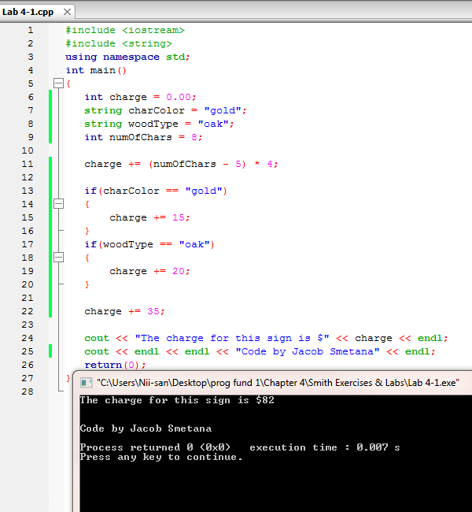

Exercise 4-2.

1. What is the exact output when this program executes?

Customer Number: 847-5551234

Called Number: 630-5557890

The charge for this call is $12.50

1. What is the exact output if the value of **callMinutes** is changed to **20**?

Customer Number: 847-5551234

Called Number: 630-5557890

The charge for this call is $5

1. What is the exact output if the expression in the **if** statement is changed to **callMinutes >= MAX_MINS**?

Customer Number: 847-5551234

Called Number: 630-5557890

The charge for this call is $12.50

1. What is the exact output if the variable named **calledAC** is assigned the value **847** rather than the value **630**?

Customer Number: 847-5551234

Called Number: 847-5557890

The charge for this call is $5

Lab 4-2.

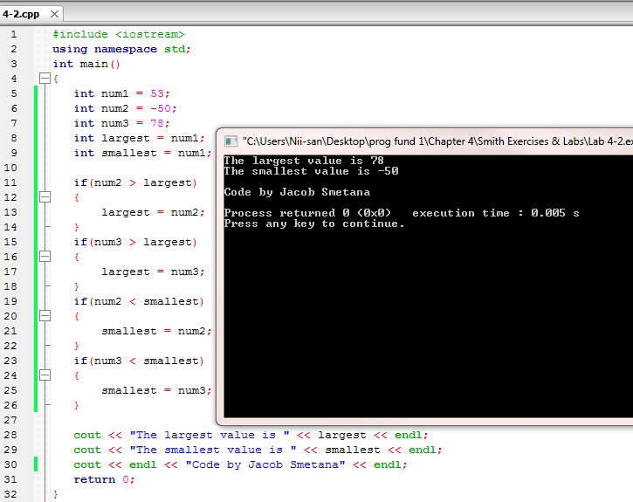

Exercise 4-3.

1. What is the exact output when this program executes if the user enters **“bath”**?

The charge for a doggy bath is $12.00

1. What is the exact output when this program executes if the user enters **“shave”**?

We do not perform the shave service.

1. What is the exact output when this program executes if the user enters **“BATH”**?

We do not perform the BATH service.

Lab 4-3.

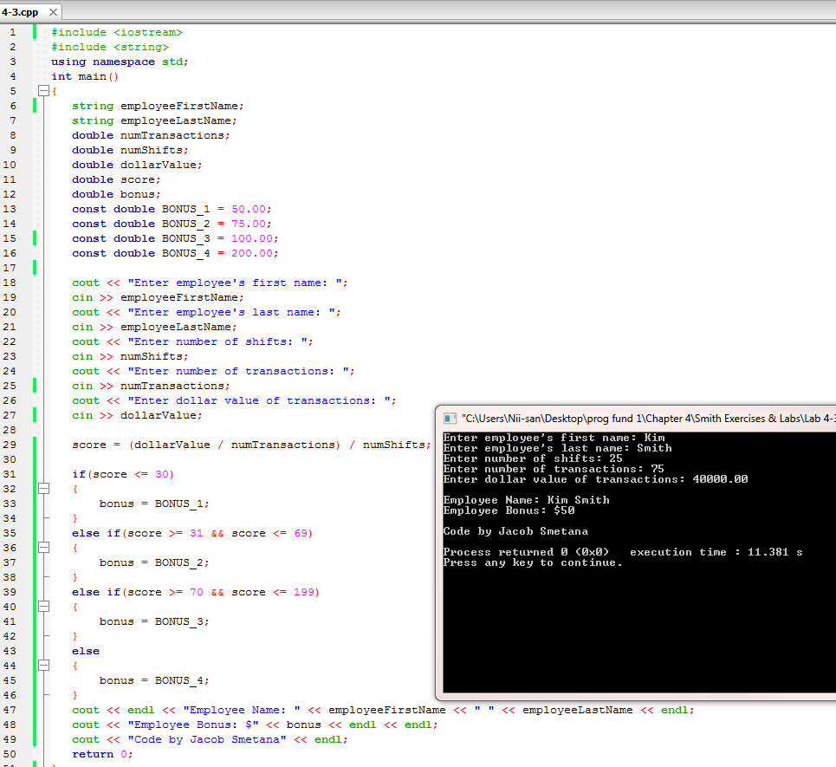

Exercise 4-4.

1. What is the value of **answer** if the value of **numValue** is **10**?

25

1. What is the value of **answer** if the value of **numValue** is **20**?

0

1. What is the value of **answer** if the value of **numValue** is **5**?

30

1. What is the value of **answer** if the value of **numValue** is **17**?

0

1. Is the **break** statement in the **default** case needed? Explain.

The break isn’t needed because the closing curly brace immediately proceeds it.

Lab 4-4.

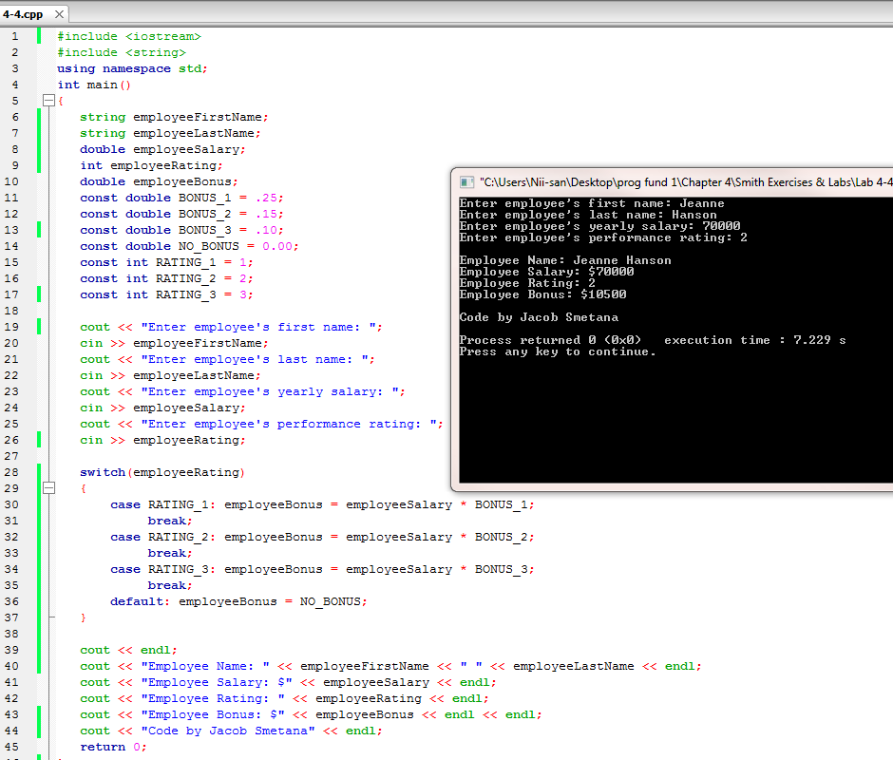

Exercise 4-5.

1. What is the exact output when this program executes if the customer’s name is Chas Matson and the drink is **Coke**?

Customer’s First Name: Chas

Customer’s Last Name: Matson

Drink: Coke

1. What is the exact output when this program executes if the customer’s name is Chas Matson and the drink is **Pepsi**?

Customer’s First Name: Chas

Customer’s Last Name: Matson

Drink: Pepsi

1. What is the exact output from this program when

**if(drink == “Coke” || drink == “Pepsi”)** is changed to

**if(drink == “Coke” && drink == “Pepsi”)** and the customer’s name is Chas Matson and the drink is **Pepsi**?

Chas Matson does not prefer Coke or Pepsi.

1. What is the exact output from this program when

**if(drink == “Coke” || drink == “Pepsi”)** is changed to

**if(drink == “Coke” || drink == “Pepsi” || drink == “coke” || drink == “pepsi”)** and the customer’s name is Chas Matson and the drink is **coke**? What does this change allow a user to enter?

Customer’s First Name: Chas

Customer’s Last Name: Matson

Drink: coke

The change allows the user to enter “Coke” or “Pepsi” without the first letter being case sensitive.

Lab 4-5.

